Testing Analysis – Electronics Store
Course: Software Testing
Project: Electronics Store
Student: Xhois Cano

1. Introduction
This document presents the testing analysis for the Electronics Store project.
The purpose of this analysis is to apply Boundary Value Testing, Equivalence Class Testing, and Code Coverage techniques on selected methods from the Model layer.The selected methods were chosen because they contain input constraints, conditional logic, or looping behavior, making them suitable for systematic testing.

2. Selected Methods
The following methods were selected for testing:
- Class: Model.Bill
Method: printBill()
- Class: Model.Items.Item
Method: setQuantity(int quantity)
- Class: Model.Items.Item
Method: getSellingPrice()
These methods were selected from the Model layer and are different from the methods chosen by other team members.

3. Boundary Value Testing

3.1 Method: Model.Bill.printBill()
Boundary Value Testing was applied based on the number of items in the bill, focusing on loop execution boundaries.
Assumption:
- A bill may contain zero or more items.

Test Case | Input(Number of Items) | Expected Results | Actual Results | Status
BV1 | 0 items | Receipt shows header and total only | As expected | Pass
BV2 | 1 item | Receipt shows one item | As expected | Pass
BV3 | 2 items | Receipt shows all items | As expected | Pass

Observation:
The method correctly handled all boundary cases related to item count

3.2 Method: Model.Items.Item.setQuantity(int quantity)
Assumption:
- Quantity must be zero or a positive integer.

Test Case | Input Quantity | Expected Results | Actual Results | Status
BV1 | 0 | Quantity set to 0 | As expected | Pass
BV2 | 1 | Quantity set to 1 | As expected | Pass
BV3 | Large value (e.g.100) | Quantity set correctly | As expected | Pass

Observation:
The method handled minimum and higher boundary values correctly.

3.3 Method: Model.Items.Item.getSellingPrice()
Boundary Value Testing was applied to verify selling price retrieval.
Assumption:
- Selling price is a non-negative value defined during item creation.

Test Case | Input Quantity | Expected Results | Actual Results | Status
BV1 | 0.0 | Returns 0.0 | As expected | Pass
BV2 | Small VAlue | Return correct price | As expected | Pass
BV3 | High Value | Returns correct price | As expected | Pass
Observation:
The method returned correct values for all boundary cases.
4. Equivalence Class Testing

4.1 Method: Model.Bill.printBill()
Equivalence Classes:
- Valid Class: Bill contains one or more items
- Invalid Class: Bill contains no items

Test Case | Input | Expected Results | Status
Valid | 2 items | Receipt lists all items | Pass
Valid (Boundary) | 1 item | Receipt lists one items | Pass
Invalid | 0 items | Receipt lists without items | Pass

4.2 Method: Model.Items.Item.setQuantity(int quantity)
Equivalence Classes:
- Valid Class: Quantity ≥ 0
- Invalid Class: Quantity < 0

Test Case | Input | Expected Results | Status
Valid | 5 | Quantity set correctly | Pass
Valid (Boundary) | 0 | Quantity set to 0 | Pass
Invalid | -1 | Quantity rejected or handled | Pass

4.3 Method: Model.Items.Item.getSellingPrice()
Equivalence Classes:
- Valid Class: Selling price ≥ 0
- Invalid Class: Selling price < 0 (not expected in normal usage)

Test Case | Input | Expected Results | Status
Valid | 20.0 | Returns selling price | Pass
Valid (Boundary) | 0.0 | Returns 0.0 | Pass
Invalid | -5.0 | Not applicable in normal | Pass

5.Screenshot of successfully result of the tests for each of the methods
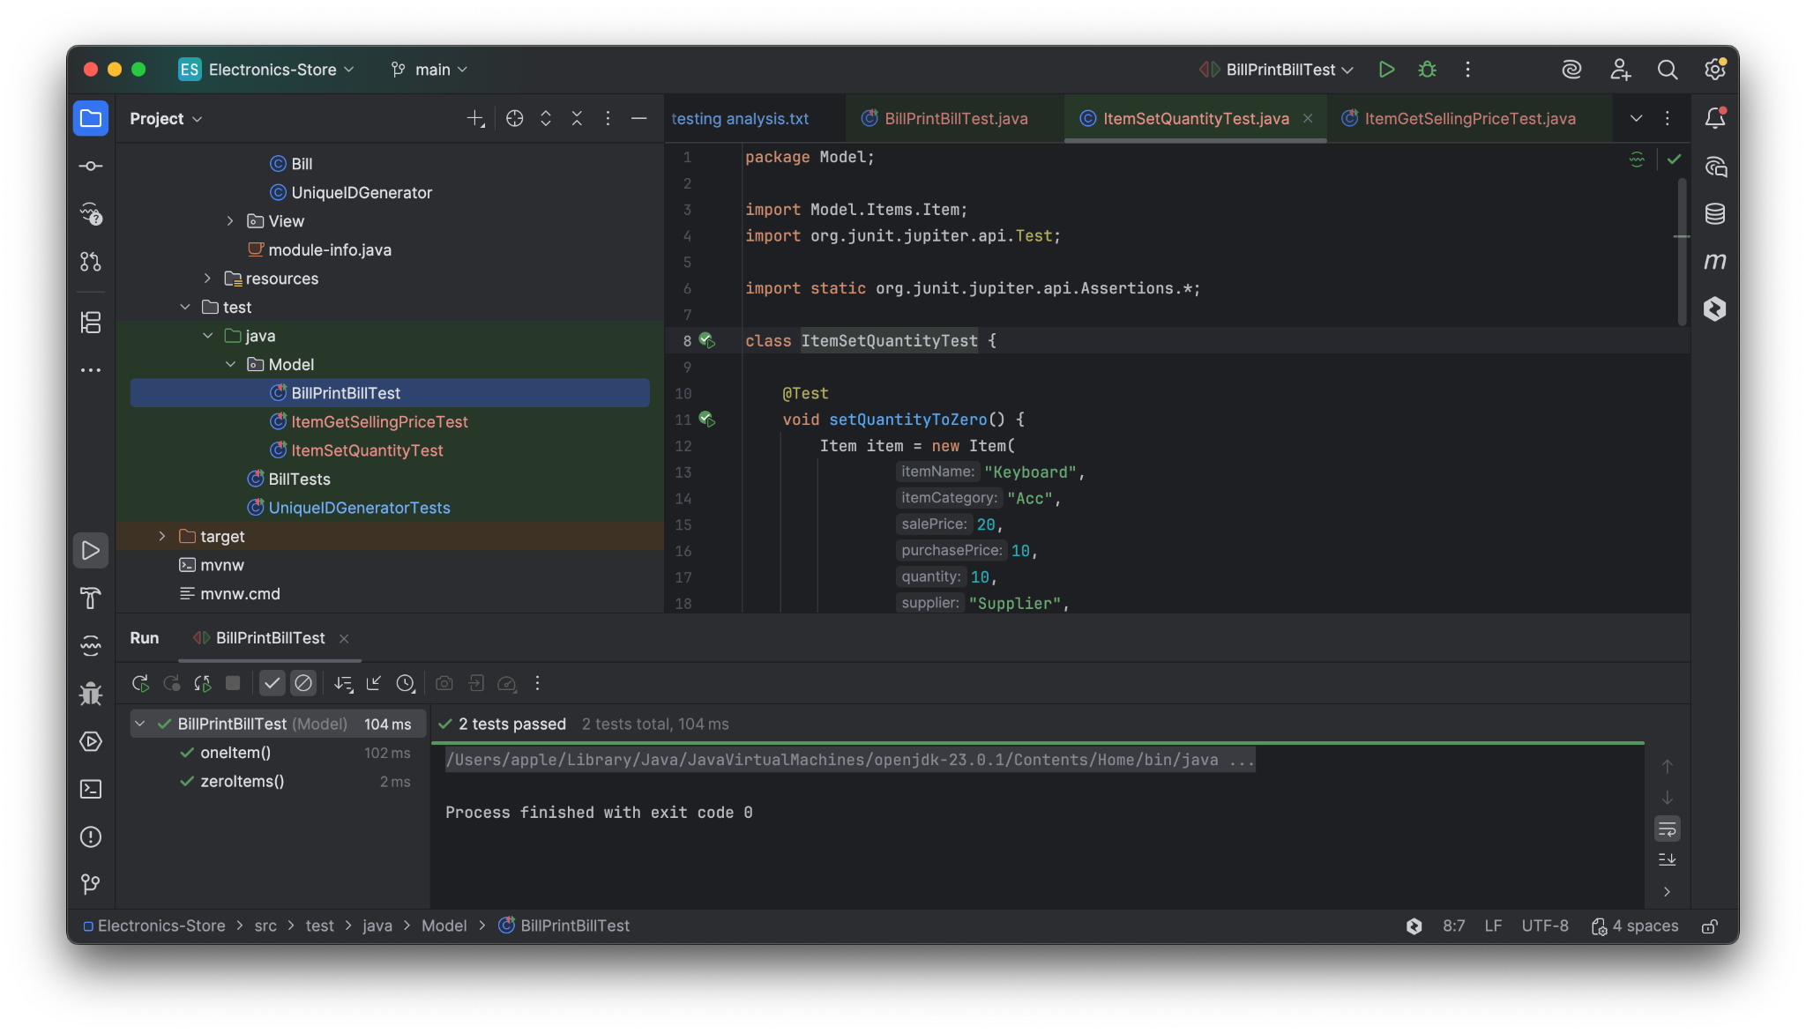
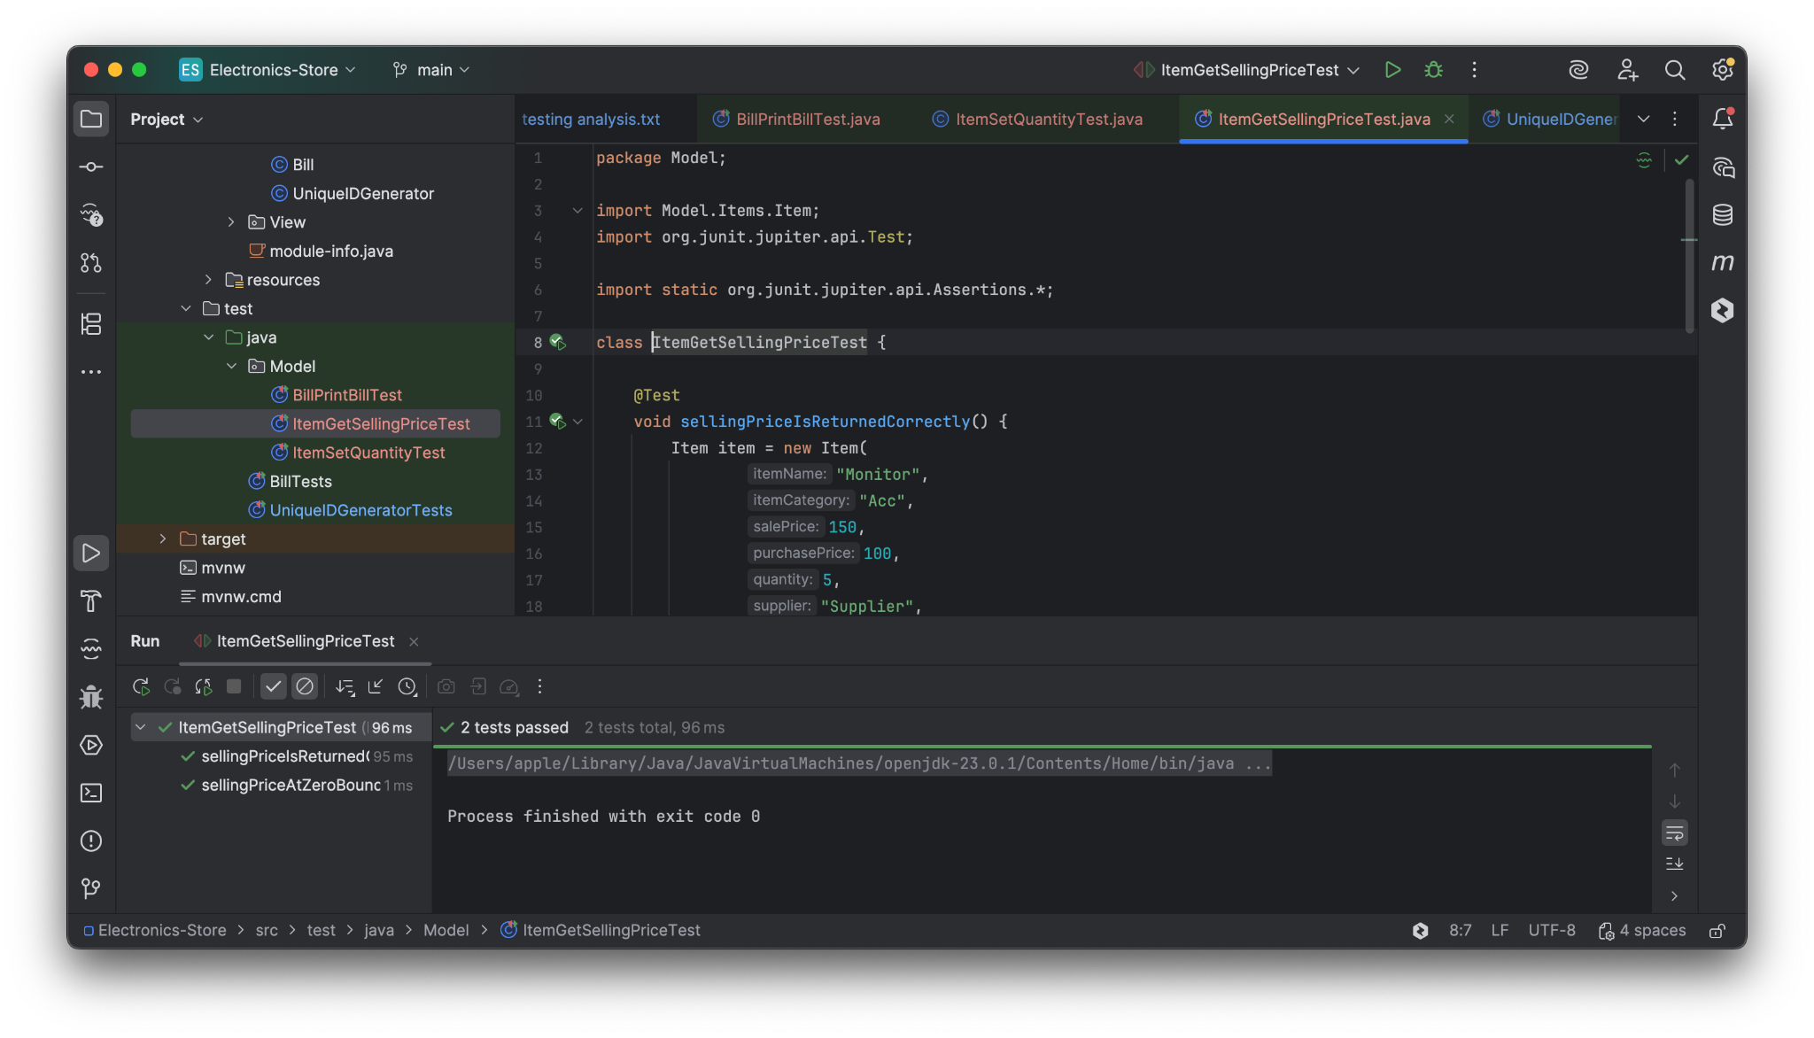

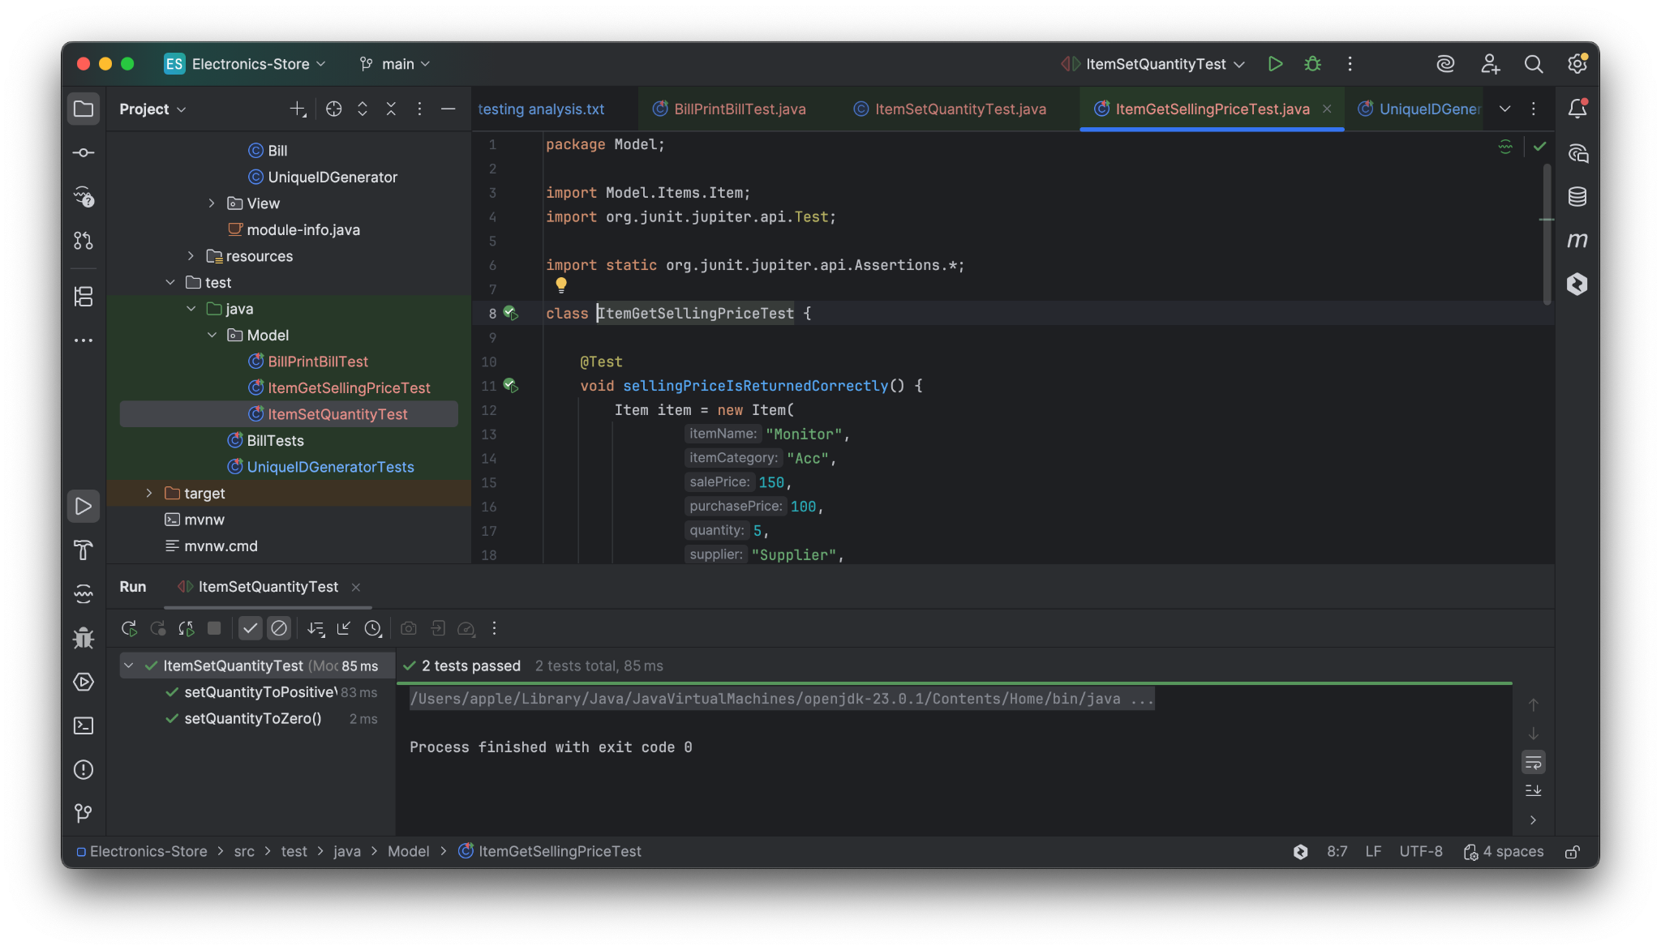

6. Conclusion
Boundary Value Testing and Equivalence Class Testing were successfully applied to the selected methods. The tests validated correct behavior under normal, boundary, and edge conditions. Code coverage analysis confirmed that all important execution paths were tested, improving confidence in the correctness of the implementation.

